

**<<F-Gear>>**

**Software Design Document**

– Ho Chi MInh, September 2022 –

**Table of Contents**

I. Overview 3

1. Code Packages 3

2. Database Schema 3

II. Code Designs 4

1. <Feature/Function Name1> 4

a. Class Diagram 4

b. Class Specifications 4

c. Sequence Diagram(s) 4

d. Database queries 5

2. <Feature/Function Name2> 5

III. Database Tables 5

1. <Table name 1> 5

2. <Table name 2…> 5

# I. Overview

## 1. Code Packages/Namespaces

*[Provide the package diagram for each sub-system. The content of this section including the overall package diagram, the explanation, package and class naming conventions in each package. Please see the sample and description table format below – following Java project naming convention]*

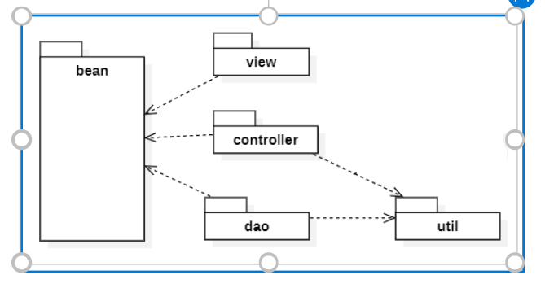

***Package descriptions & package class naming conventions***

|  |  |  |
| --- | --- | --- |
| **No** | **Package** | **Description** |
| *01* | *Bean* | *JavaBeans are classes that encapsulate many objects into a single object (the bean)* |
| *02* | *View* | *web app user interface* |
| *03* | *Controller* | *where to navigate requests, responses* |
| *04* | *Dao* | *Contains methods for handling the object's data* |
| *05* | *Util* | *Where to connect to the database* |

## 2. Database Schema

*[Provide the tables relationship like example below – following MySQL database naming convention]*

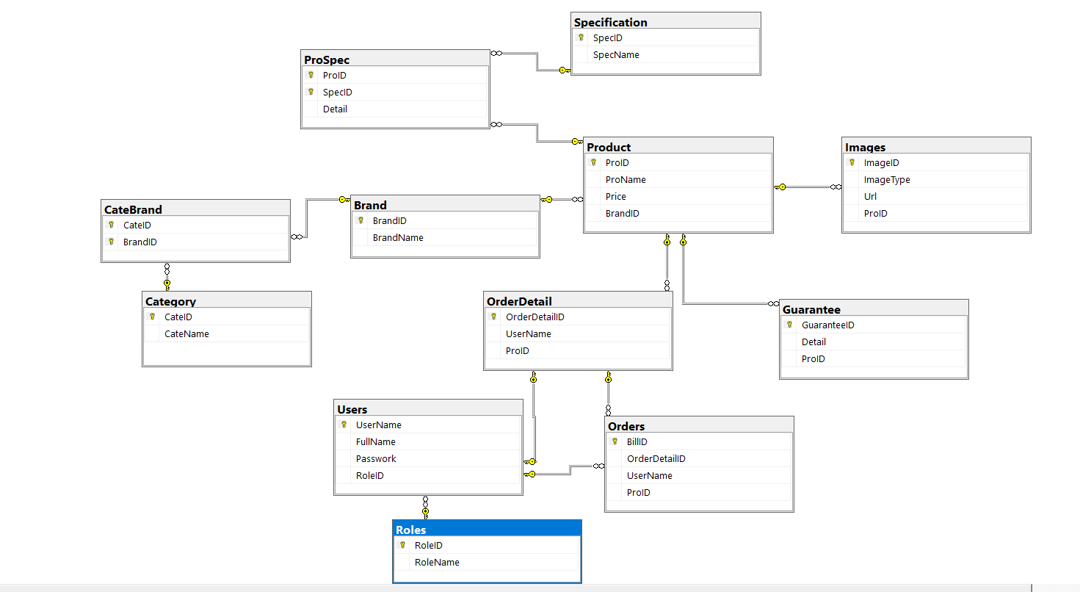

***Table descriptions & package class naming conventions are as below***

|  |  |  |
| --- | --- | --- |
| **No** | **Table** | **Description** |
| *01* | *Order Details* | Table *Order* Details contains a list of items that the user has bought |
| *02* | *Brand* | Table Brand contains the names of the brands of the products. |
| *03* | *Product* | Table Product contains product description information |
| *04* | *Images* | *Table Images contain pictures of products.* |
| *05* | *Category* | Table Category contains the main items the store sells |
| *06* | *Prospec* | Table Prospec contains configuration details of products |
| *07* | *Brand* | Table Brand is used to contains the name of product brand |
| *08* | *CateBrand* | Table CateBrand is used to show brand correspond to product |
| *09* | *Order* | Table Bill used to contain User purchase information |
| *10* | *Specification* | Table Specification contains configuration type names of products |
| *11* | *Guarantee* | Table Guarantee contains warranty information of products |
| *12* | *User* | Table User contains user information and account |
| *13* | *Role* | Table Role used to authorize web app users |

# II. Code Designs

## 1. <Feature/Function Name1>

*[Provide the detailed design for the function <Feature/Function Name1>. It include Class Diagram, Class Specifications, and Sequence Diagram(s)]*

### a. Class Diagram

*[This part presents the class diagram for the relevant feature]*

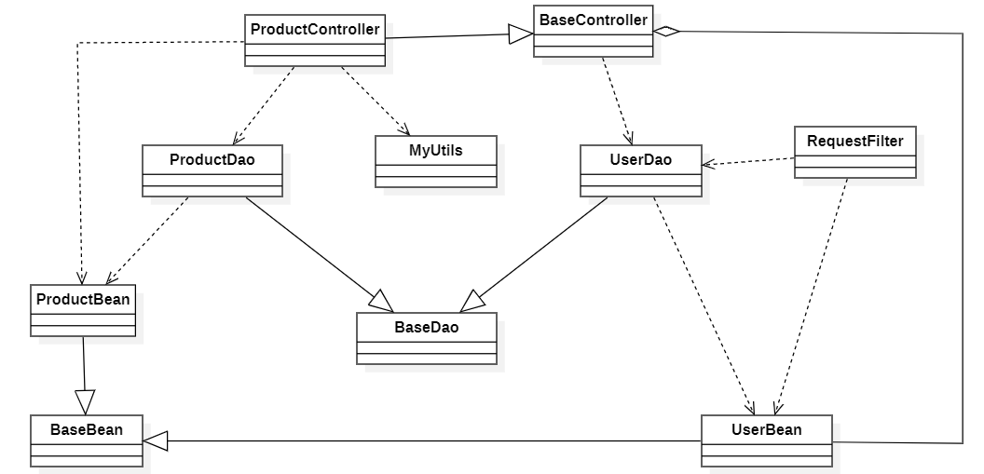

### b. Class Specifications

*[Provide the description for each class and the methods in each class, following the table format as below]*

#### XYZ Class

*[Provide the detailed description for the class methods]*

|  |  |  |
| --- | --- | --- |
| **No** | **Method** | **Description** |
| *01* | *<method name>* | *<Description of the method, including the inputs, outputs & internal method processing>* |
|  |  |  |

#### ABC Class

***Class Methods***

*[Provide the detailed description for the class methods]*

|  |  |  |
| --- | --- | --- |
| **No** | **Method** | **Description** |
| *01* | *<method name>* | *<Description of the method, including the inputs, outputs & internal method processing>* |
|  |  |  |

### c. Sequence Diagram(s)

*[Provide the sequence diagram(s) for the feature, see the sample below]*

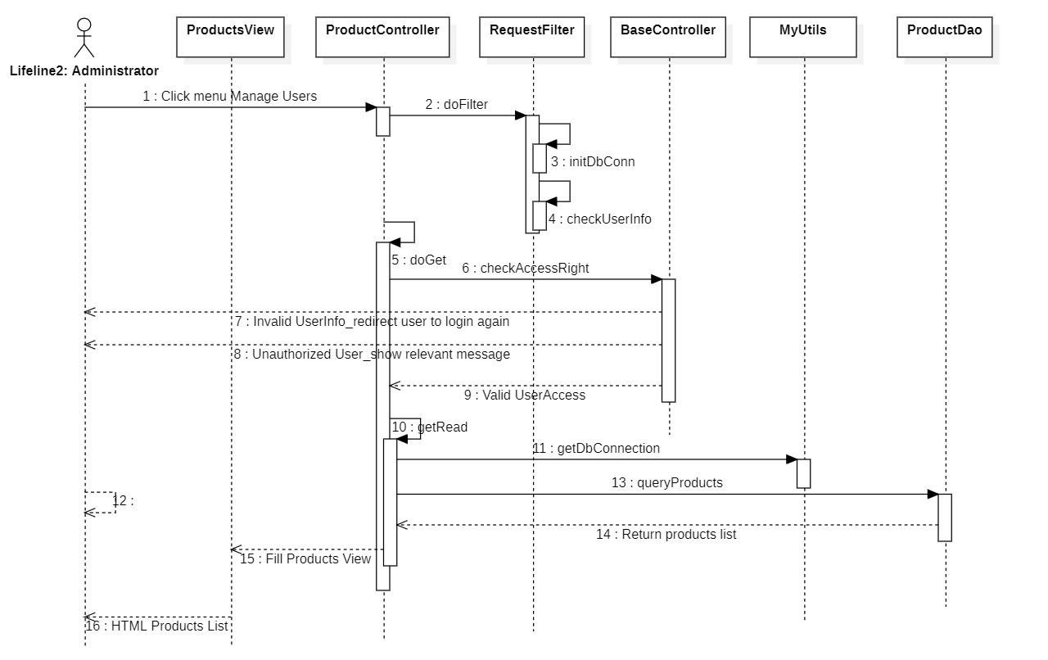

### d. Database queries

*[Provide the detailed SQL (select, insert, update...) which are used in implementing the function/screen]*

## 2. <Feature/Function Name2>

…

# III. Database Tables

## 1. <Table name 1>

*[Give some lines about the table here>>*

*[Table fields, in the form of table format as below]*

|  |  |  |  |  |  |  |  |
| --- | --- | --- | --- | --- | --- | --- | --- |
| **#** | **Field name** | **Type** | **Size** | **Unique** | **Not Null** | **PK/FK** | **Notes** |
| 1 | Field name1 |  |  |  |  |  |  |
| 2 | Field name2 |  |  |  |  |  |  |

## 2. <Table name 2…>